Diocese of Down and Dromore Crib Service Resource Pack

In this resource:
- ‘Introducing Crib Services’ – some things to consider when planning and preparing
- Outline Shape for a Crib Service
- Scripts for ‘characters’ in the service
- Some liturgical resources (including action prayers) for compiling an order of service

Introducing Crib Services
A Crib Service is a chance to tell the story of the Nativity in a different way. Unlike a Nativity play with characters who are dressed up, it usually focusses on a more traditional Nativity Scene.
The material in this resource pack is intended to give you the tools to construct and host a Crib Service. There is sufficient material to allow you to lift a service directly out of the resource pack, but there is flexibility in every aspect of the service – from the liturgical material you deploy, to the bible readings you choose, characters upon whom you focus, hymns and songs you select and prayers you use.

Telling the Story
The focus of the Crib Service is gathering around the Nativity Scene to tell the story of Christmas – there is a variety of ways to do this, but the most obvious is through the characters who are part of the story. These resources offer a particular focus on Mary and Joseph, the Shepherds and the Wise Men/Magi and use first person monologues to tell their story. You may choose another option – perhaps there are video resources available, or you may have a gifted storyteller who can explain the events in the third person instead.

Catching People’s Attention
Where possible the Nativity Scene should be clearly visible at the front of the Church.
- It could be a traditional Nativity Scene on a table or pedestal
- Perhaps your Parish has the resources to make Crib Scene that is even more visually striking –
  - using mannequins or papier mache to make larger models and dressing them in real clothes
  - building a makeshift stable in the Church or hall if space allows
  - using different materials, fabrics (like straw and wool) and colours to make the scene as visually varied as possible
  - within COVID-19 restrictions you may be able to use other means of sensory engagement – such as touch and smell

COVID and the Crib
These resources were devised during 2020 in such a way as to limit movement around the Church – the Crib Scene was already in place, and one person led the service and read the parts. Care should be taken to make the service as safe as possible in line with parish risk assessments and in light of the latest government guidance. At time of writing, this guidance allows considerably more flexibility around movement and involving additional voices.

Involving people in the service
You should consider how to involve as many people as possible in a safe way:
- ask children (and adults) to place the characters in the crib scene as they are featured to introduce an element of movement
- get readers for the bible passage(s), prayers and monologues
- can parishioners help to put the crib scene together in the days leading up to the service?
- could the reading about the shepherds be prerecorded in a local farm with the reader surrounded by sheep? Or could Mary/Joseph’s monologue be filmed with a donkey in shot? For that matter, could Mary bring a donkey to Church with her on the day?!

Outreach opportunities
Family friendly Christmas Services have the potential to attract visitors from the wider community and to gather in those on the fringes of parish life. You should give thought to maximising the outreach potential of the service:
- When? Is a Sunday morning in Advent the best time? What about a weekday near to Christmas Day after schools have broken up? Could early evening (when it is dark) add something to the atmosphere?
- Where? In most cases, the Church building or hall is the best and most obvious venue, but this may not always be the case. Is there a shared community space that may help you to attract more people?
- Take Home: Can you give away a gift to those present e.g. a Gospel or outreach booklet like ‘Why Christmas?’

The liturgical material has been drawn and adapted from various sources:
- Common Worship Times and Seasons
- New Patterns for Worship
- Liturgical resources prepared by Nick Harding
- Other original material prepared for this service
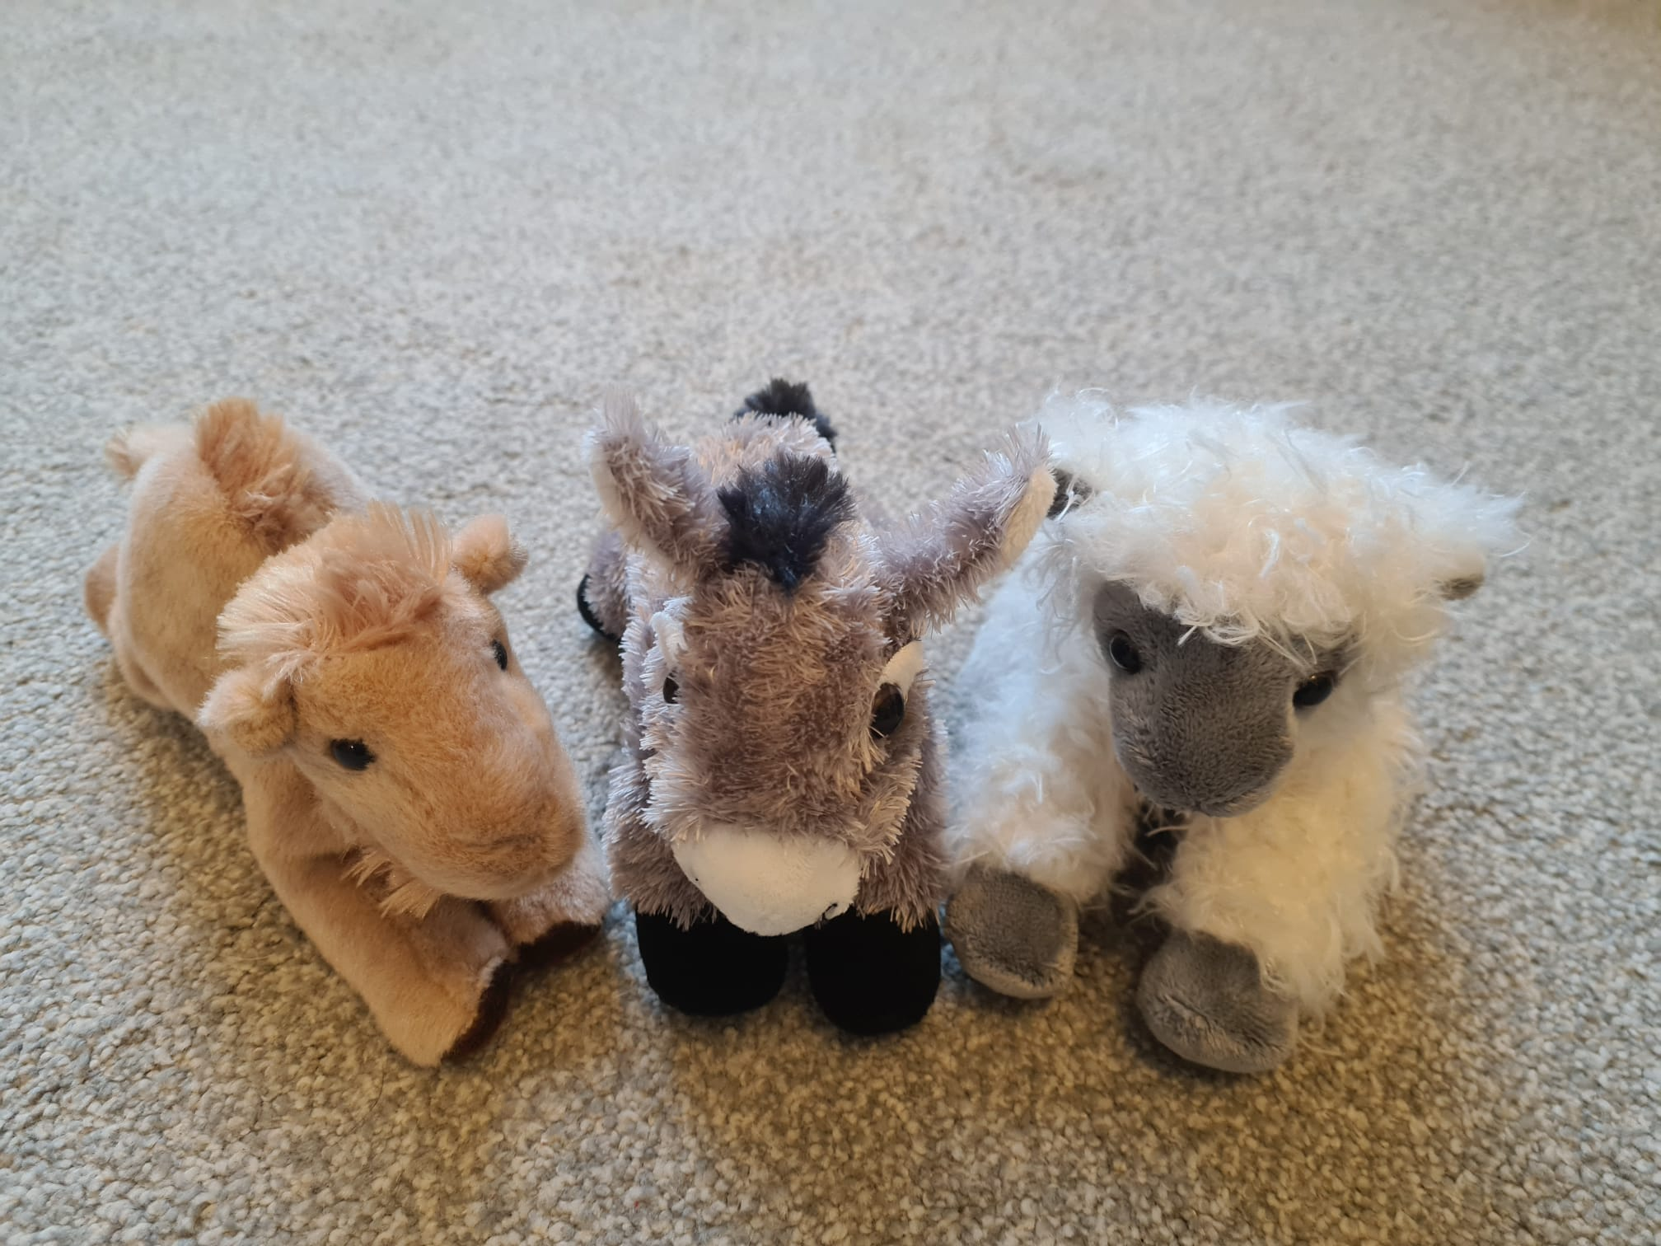
Running Order for a Crib Service
This structure is based around three monologues telling the story of the Crib from the first person perspectives of some of the participants in the Nativity narrative. If length is an issue, consider either using reading or monologue for each part of the story, rather than both. Prerecording readings or monologues uses another medium which will help to hold people’s attention.

Gathering
A Candle is lit
This may be the appropriate candle on the Advent Wreath

A Hymn/Song or Carol is sung

The Service is introduced, followed by a
Bidding Prayer

A Hymn/Song or Carol is sung

(Penitence)

Ministry of the Word
Bible Reading: The Angel Appears to Joseph or The Annunciation

The First Journey: Mary and Joseph

A Hymn/Song or Carol is sung

Bible Reading: The Shepherds and the Angels

The Second Journey: The Shepherds

A Hymn/Song or Carol is sung

Bible Reading: The Wise Men and Herod

The Third Journey: The Wise Men

Response
Praying at the Crib

Dismissal
A Hymn/Song or Carol is sung

Closing Prayer and Blessing
Character Monologues
At the start of each monologue, an image of a donkey/sheep/camel could appear on a screen, be printed in the order of service or be highlighted in the Crib Scene. You could place a stuffed animal in view at the front each time.

Joseph and Mary
Leader
I wonder what Mary and Joseph thought as they made their journey?

Image of a Donkey – on screen or physically present

[Joseph]
[It was a long journey. Long and slow.
I mean it would be long and slow over rough ground in normal circumstances,
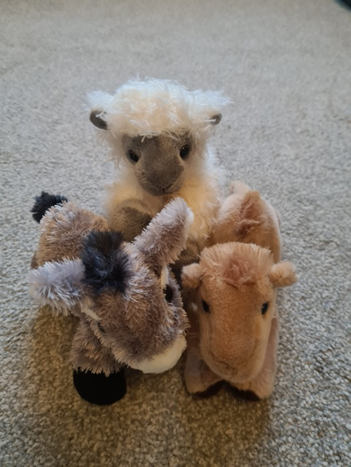
but Mary was about to have a baby.
I know you’re either pregnant or you’re not,
but Mary wasn’t just pregnant.
She was really pregnant!
It was a strange journey,
at the end of a strange year for us.
A difficult year.
Not the year we expected when we got engaged.
We had great plans,
but nobody predicted what the year ahead held.
Mary fell pregnant.
Angels came to tell us. Angels!
It was amazing, but it was still a tough year.
We knew what was going on,
but not everyone believed us.
There were lots of funny looks and knowing glances.
Here we are. Mary, me…and a donkey.
It is a long way, and it’s been a long year,
but we just get our heads down and carry on.
A bit like the donkey.
And the most amazing thing? Mary.
She’s heavily pregnant, exhausted and uncomfortable.
I asked her how she was feeling and d’you know what she said?
Excited! She’s excited!
Not about a census, or a trip to Bethlehem.
Mary is excited about the child.
The baby that’s about to arrive.
She knows he’s going to be special.
She knows that he won’t change just our lives.
Mary knows that our dark year,
all the pain of this dark world,
will feel different when he arrives.
He will come, and he will change things.
He will bring light.]

The donkey (image) is removed.

Leader and Congregation
In our dark world: Jesus, bring light.
In our dark hearts: Jesus, bring light.

OR

[Mary]
[It was a long journey. Long and slow.
I mean it would be long and slow over rough ground in normal circumstances,
but I was about to have a baby.
I know you’re either pregnant or you’re not,
but I wasn’t just pregnant.
I was really pregnant!
It was a strange journey,
at the end of a strange year for us.
A difficult year.
Not the year we expected when we got engaged.
We had great plans,
but nobody predicted what the year ahead held.
I fell pregnant.
An angel came to tell me. An angel!!
It was amazing, but it was still a tough year.
We knew what was going on,
but not everyone believed us.
There were lots of funny looks and knowing glances.
So here we are. Joseph, me…and a donkey.
It is a long way, and it’s been a long year,
but we just get our heads down and carry on.
A bit like the donkey.
And the most amazing thing?
I’m heavily pregnant, exhausted and uncomfortable.
But I’m not thinking about any of those things.
I’m…excited!
Not about a census, or a trip to Bethlehem.
I’m excited about the child.
The baby that’s about to arrive.
I know he’s going to be special,
that he won’t change just our lives.
I know that this dark year,
all the pain of this dark world,
will feel different when he arrives.
He will come, and he will change things.
He will bring light.]

Shepherds
Leader
We’ve thought about Mary and Joseph, but they weren’t the only people who journeyed to Bethlehem that first Christmas. I wonder what the Shepherds thought as they made their journey?

Image of a sheep – on screen or physically present.

Shepherd
The thing about being a shepherd is – you know what you’re getting into.
Sheep, obviously. Outdoors, come rain, hail or shine.
Not a lot of people.
It can be a bit lonely, but you don’t have many arguments!
I mean, we work together too, but we like our peace and quiet. The point is, it’s predictable.
Morning. Evening. Winter. Spring. Summer. Autumn.
There’s the odd wild animal to chase off.
Or a lost sheep to find.
Still, that’s all part of the job when you’re a shepherd.
You don’t expect anything out of the ordinary.
You DON’T expect angels. Imagine it.
Not a child with a note. Not a soldier with a message.
Not an orchestra with a fanfare. ANGELS!
A choir, singing beautiful music like you’ve never heard.
It was…so good I can’t describe it.
And they told us: ‘A Saviour has been born in Bethlehem.’
So we didn’t hang around.
We got there, and we found the Saviour.
He didn’t look it, among the animals and hay.
Literally all in a day’s work for a shepherd.
For a tiny moment, we wondered if we were in the right place
Then we remembered.
We weren’t here because of a rumour or gossip.
We were here because of angels.
That’s when I realised. He WAS the Saviour .
Here he was, like he could have been the son of a shepherd rather than the Son of God.
Here we were. Poor shepherds at the throne of a king.
And it looked like something we saw every day.
A manger. A simple feeding-box.
Here he is, with us.
Here he is, for us.
Our God.
It’s amazing!

The sheep (image) is removed.

Leader and Congregation
In our dark world: Jesus, bring light.
In our dark hearts: Jesus, bring light.

The Wise Men/Magi
Leader
Mary and Joseph. The Shepherds. That leaves us with our final characters. So we ask…what the Wise Men/Magi thought as they made their journey?

Image of a camel – on screen or physically present.

Magi
We knew we were going to find something special.
It was in the stars.
We nearly got it right. We found Judea.
We were looking for a king. So of course we went to the palace.
Where we found someone who called himself a king.
But he wasn’t. He was brutal and bad. Herod.
Eventually we found the real king.
He was gentle and pure; helpless and perfect.
We looked and sounded different from everyone in that little town; with our camels,
our clothes that must have looked exotic,
our accents that must have sounded strange
and our expensive gifts that must have looked out of place.
We knew we shouldn’t belong. But we knew we did belong.
We knew as soon as we entered into the presence of this tiny baby that there was a place for us.
A place in God’s plan for people who look and sound and seem different or out of place.
We knew that his light would be a light for all the nations.
We knew that he was the light of the world.

The camel (image) is removed.

Leader and Congregation
In our dark world: Jesus, bring light.
In our dark hearts: Jesus, bring light.

Liturgical Resources

Lighting the Candle
Advent 1
As we light the first candle on our Advent Wreath,
We remember today that the Patriarchs
were part of the story of God’s promise of salvation
made complete in Jesus, the light of the World.
In our dark world: Jesus, bring light.
In our dark hearts: Jesus, bring light.

Advent 2
As we light the second candle on our Advent Wreath,
We remember today that the Prophets
Told us of God’s promise to send his Saviour Jesus,
the light of the World.
In our dark world…

Advent 3
As we light the third candle on our Advent Wreath,
we remember today that John the Baptist came
to point the way to Jesus, who is the light of the world.
In our dark world…

Advent 4
As we light the fourth candle on our Advent Wreath,
we remember today the Virgin Mary,
who responded with joy to the news of the coming
of Jesus, the light of the world.
In our dark world…

Christmas Eve/Day
As we light the final candle on our Advent Wreath
we celebrate the coming of the Lord Jesus,
the Light of the World.
In our dark world…

Generic
As our candle is lit, we remember the words of St John:
‘The light shines in the darkness,
but the darkness could not overcome it.’
In our dark world…

Bidding Prayer
The light from the candle is a reminder that the Lord Jesus is with us.
At the start of our worship, let us pause and recognise his presence with us:
Jesus, we invite you into our church.
Jesus, we invite you into our church.
Jesus, we invite you into our minds.
Jesus, we invite you into our minds.
Jesus, we invite you into our hearts.
Jesus, we invite you into our hearts.
In our dark world: Jesus, bring light.
In our dark hearts: Jesus, bring light.

OR

We get ready for the coming season, as we gather we get ready.
We get ready to celebrate Jesus, as we gather we get ready.
We get ready to meet Jesus again, as we gather we get ready.
In our dark world: Jesus, bring light.
In our dark hearts: Jesus, bring light.

Penitence
Jesus came into the world
so God’s promises of forgiveness could come to pass.
We bring him the things we have done wrong,
and ask for his forgiveness in our lives:
The Virgin Mary accepted your call to carry the Christ Child.
When we don’t hear your call: Lord, forgive us.
The shepherds left their flocks to see you.
When we don’t come to you: Lord, forgive us.
The Magi followed the star to find you.
When we don’t look for you: Lord, forgive us.

Suggested Bible Passages
The Angel appears to Joseph Matthew 1:18-25
The Annunciation Luke1:36-38
The Shepherds Luke 2:8-20
The Magi/Wise Men Matthew 2:1-12

Praying at the Crib
The prayers should be introduced with four simple actions which should allow all those present to join with actions as well as in the verbal response. The actions happen each time the word(s) is/are said:

Be our light this Christmas Hands open in front of yourself, facing up
Trust Arms crossed over chest/heart
Listen Cupping ears in the universal sign for listening
Worship Hands together in the universal sign for praying

Light of the stars, light of the world,
Be our light this Christmas
We come here from our homes and safe places and ask you, Jesus to help us:
TRUST like Mary and Joseph
LISTEN like the Shepherds
WORSHIP like the wise men.
As we gather to remember and celebrate…
As Mary and Joseph TRUSTED the light of the angel,
As they heard the light of his message;
Jesus, help us to TRUST you to be the one who saves us,
the one who always loves us and the one who protects us.
Light of the stars, light of the world,
Be our light this Christmas
As the shepherds LISTENED when they saw light in the sky,
And so visited the light of the world;
Help us to LISTEN when people point us to you,
and help us like the shepherds to come to you
with open hearts so we can know your Holy Spirit more and more.
Light of the stars, light of the world,
Be our light this Christmas
As the Wise Men followed the star so they could WORSHIP you
As the light led them on their journey,
Lead us in our lives to WORSHIP you
In new and exciting ways each and every day.
Jesus, help us find time and space to WORSHIP you this Christmas,
Even as everything and everyone gets very busy.
Light of the stars, light of the world,
Be our light this Christmas
We join our prayers together in the words that Jesus taught us, saying:
Our Father, who art in heaven…

Closing Prayer and Blessing
Give us, O God, such love and wonder
that, with Mary and Joseph, the Shepherds and the Magi,
we may come to adore the holy Child, the promised King,
and with our gifts worship him,
who lives and reigns with you in the unity of the Holy Spirit,
one God, now and for ever. Amen.
Christ the sun of righteousness shine upon you,
gladden your hearts and scatter the darkness from before you,
and the blessing of God Almighty,
Father, Son and Holy Spirit, be with you all evermore. Amen.
Into our dark world: we bring the Lord Jesus.
Go in peace to love and serve the Lord: in the name of Christ. Amen.

Hymns/songs/carols
There are many traditional carols which tell the story of the specific characters from the Nativity narrative, as well as other well-known carols. Give thought to using other hymns and worship materials as well – for example, there are many hymns and songs around the theme of light which could be used as the first hymn.

Hymns and songs around the theme of light
Christ be our Light
Shine, Jesus, shine
Light of the world (Here I am to worship)
This little light of mine

